|  |
| --- |
|  |
| 新概念 3 册 |
| Lesson27 |

Lesson 27

**Nothing to sell and nothing to buy**

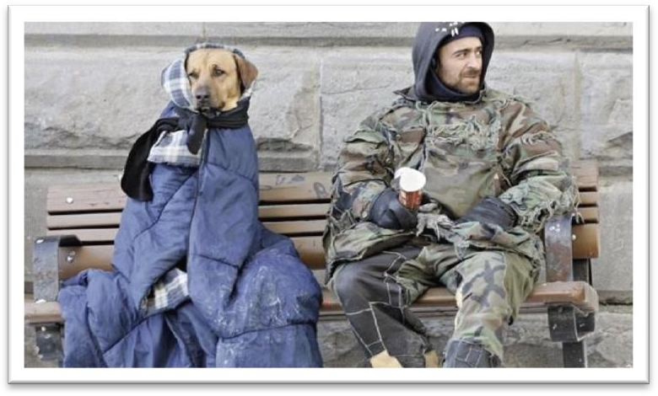

**philosopher [fə'lɒsəfə(r)]**

**n. 哲学家**

philosopher philosophy “phil” = love

philology philologist

“soph” = wisdom

sophomore sophisticated

spiritual ['spɪrɪtʃuəl] adj. 精神的

spiritual spiritual civilization

material material civilization

mental mental labor

manual / physical ~ labor intellectual intellectual development intelligent intelligent beings **grudge [ɡrʌdʒ]**

v. 吝惜，不愿意给

grudge + n. / doing

He grudges paying taxes.

He grudges the money he pays in tax.

grudging reluctant unwilling grudge（名词）恶意，怨恨

have / bear / hold a grudge 怀恨在心

She has a bad memory.

She's quick to forgive people.

Her feelings are easily hurt.

She doesn't get angry very often.

W: I wish I hadn’t hurt Mary’s feelings like that. You know I’ve never meant to.

M: The great thing about Mary is that she doesn’t hold a grudge. By tomorrow she’ll have

forgotten all about it.

Q:What does the man say about Mary? Answer: (B) She's quick to forgive people. **dignity ['dɪɡnətɪ]**

n. 尊严

beneath one’s dignity

Arguing with you is beneath my dignity. self-respect

self-esteem indignity

shame / disgrace / humiliation indignation

anger / rage / fury **deliberately [dɪ'lɪbərətli] adv. 故意地**deliberately intentionally

on purpose accidentally by accident by chance **afflict [ə'flɪkt]**

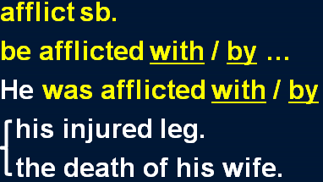v. 使苦恼，折磨

inflict inflict sth. on sb. Please don’t inflict your love on me. conflict in conflict

The employers and workers are still in conflict. sb. suffer (from) sth.

sth. distress sb.

sth. torture / torment / rack sb.

God Almighty, where are you when the world is racked by war?

ease [i:z]

**n. 容易；舒适**

with ease=easily

He passed the exam with ease.

at ease=in comfort=comfortably He sat there at ease.

contempt [kən'tempt]

**n. 蔑视**

hold … in contempt contemptuous despise

scorn

look down on / upon …

envious ['enviəs] adj. 羡慕的

be envious of … envy You lucky dog, I envy you.

You are my envy.

His talent is the envy of his colleagues. jealous

be jealous of … jealousy

It has been said that everyone lives by selling something. It is said that …

They say that … People say that …

It is reported that … It is believed that …

It is estimated that …

It must be admitted that …

It must be pointed out that … It must be stressed that …

It can be foreseen that …

live by doing 靠某种职业为生

He lives by writing. He lives by sewing.

The nomads who made these markings lived by hunting and fishing during the last Ice Age which began about 35,000 B.C. and ended about 10,000 B.C.

live on sth. 靠某种食物或生活来源为生

He lives on meat and milk. He lives on salary.

He lives on his parents.

feed on sth. 动物以……为主食

Cows feed on hay.

prey on sth. 肉食性动物以别的动物为食

Owls prey on mice.

In the light of this statement, teachers live by selling knowledge, philosophers by selling wisdom

and priests by selling spiritual comfort. in (the) light of sth. 根据……；鉴于……

Reading is thought to be a kind of conversation between the reader and the text. The reader puts questions, as it were, to the text and gets answers. In the light of these he puts further questions, and so on.

He explores such problem consciously, articulately, and frankly, first by asking factual questions, then by asking moral questions, finally by suggesting action which seems appropriate in the light of the factual and moral information which he has obtained.

I am afraid that you have to alter your _ views in light of the tragic news that has just arrived.

(A) indifferent (B) distressing

(C) optimistic (D) pessimistic

in (the) light of sth. 根据……；鉴于……

according to sth.

in accordance with sth. considering sth.

taking into account sth.

In the light of this statement, teachers live by selling knowledge, philosophers (live) by selling wisdom and priests (live) by selling spiritual comfort.

**并列句中重复的谓语动词可省略**Mary was happy, but / and / while / whereas Jane (was) miserable. Mary was happy when Jane was miserable.

parallelism 排比

Some books are to be tasted, others to be swallowed, and some few to be chewed and digested.

— Francis Bacon

Reading makes a full man, conference a ready man, and writing an exact man.



— Francis Bacon

It is said that in England death is pressing, in Canada inevitable and in California optional. Small wonder. Americans’ life expectancy has nearly doubled over the past century. Failing hips can be replaced, clinical depression controlled, cataracts removed in a 30-minutes surgical procedure.

It is said that in England death is pressing, in Canada (death is) inevitable and in California (death

is) optional. Small wonder. Americans’ life expectancy has nearly doubled over the past century. Failing hips can be replaced, clinical depression (can be) controlled, cataracts (can be) removed in a 30-minutes surgical procedure.

Though it may be possible *to measure the value of material goods in terms of money*, it is extremely difficult *to estimate the true value of the services which people perform for us*. Possible *as* it may be to measure the value of material goods in terms of money, …

Although she is beautiful, I still don’t like her. Beautiful *as* she is, I still don’t like her.

in terms of ... 以某种方式；从某个角度

In terms of money we’re rich, but not in terms of happiness.

Which sport has the most expenses training equipment, players’ personal equipment and uniforms?

(A) in place of (B) in terms of

(C) by means of (D) by way of perform: do; carry out

There are times when we would willingly give everything we possess *to save our lives*, yet we might grudge paying a surgeon a high fee *for offering us precisely this service*.

there are times when ... = sometimes

There are times when even the tiger sleeps.

There are times when silence has the loudest voice. there was a time when … = once

There was a time when the owners of shops and businesses in Chicago had to pay large sums of money to gangsters in return for 'protection'.

there are rare instances when …

= occasionally

There are rare instances when justice almost ceases to be an abstract concept.

造句：在个别情况下，爱国主义(patriotism)不再是一个空洞的口号(an empty slogan)。There are rare instances when patriotism ceases to be an empty slogan.

... we might grudge paying a surgeon a high fee for offering us precisely this service.

... we might grudge the high fee we would pay a surgeon for offering us precisely this service. She gave me $30 for my bike.

She bought my bike for $30. for nothing 免费

Advertisers discovered years ago that all of us love to get something for nothing.

造句：有时候我们愿意给为我们服务的侍者小费 (pay tips) 并称赞 (pay compliments) 他们， 但是在母亲为我们提供一样的服务的时候我们却吝惜感谢 (give thanks to …) 之辞。

There are times when we would willingly pay tips and compliments to the waiters who serve us, yet we might grudge giving thanks to our mothers for offering us precisely this service.

The conditions of society are such that skills have to be paid for *in the same way that goods are paid for at a shop*.

Such are the conditions of society that skills have to be paid for in the same way that goods are paid for at a shop.

Such is human nature that a great many people are often willing to sacrifice higher pay for the

privilege of becoming white-collar workers.

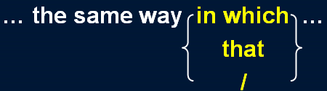

造句：学校里的情况就是这样，优等生 (A students) 受到尊敬 (respect)，正如社会上成功者(achievers) 受人景仰 (esteem) 一样。

The conditions of schools are such that A students are respected in the same way that achievers are esteemed in the society.

just as

The conditions of society are such that skills have to be paid for just as goods are paid for at a shop.

alike

He was adored by rich and poor alike. six of one and half a dozen of the other

There are six sections of each class.

He has to leave since it's almost one o'clock.

There are dozens of classes to choose from.

It doesn't matter which class the woman takes.

W: I can't decide whether to take anthropology or geology this term. M: It’s six of one and half a dozen of the other.

Q: What does the man mean?

Answer: (D) It doesn't matter which class the woman takes.

be equivalent to ...

The volcanic eruption had an explosive power equivalent to 20,000 tons of TNT.

bear a resemblance to ...

Tina bears a striking resemblance to her mother.

Your school may have done away with winners and losers, but life has not.

In some schools they have abolished failing grades; they'll give you as many times as you want to get the right answer. This doesn't bear the slightest resemblance to anything in real life.

It has been said that everyone lives by selling something. Everyone has something to sell.

topic sentence 主题句

**supporting sentences 扩展句（*论证* 和 论据）**

**concluding sentence 总结句**

It has been said that everyone lives by selling something. In the light of this statement, teachers live by selling knowledge, philosophers by selling wisdom and priests by selling spiritual comfort. *Though it may be possible to measure the value of material good in terms of money, it is extremely difficult to estimate the true value of the services which people perform for us.* There are times when we would willingly give everything we possess to save our lives, yet we might grudge paying a surgeon a high fee for offering us precisely this service. *The conditions of society are such that skills have to be paid for in the same way that goods are paid for at a shop.*

Everyone has something to sell.

It has been said that everyone lives by selling something. In the light of this statement, teachers live by selling knowledge, philosophers by selling wisdom and priests by selling spiritual comfort. *Though it may be possible to measure the value of material good in terms of money, it is extremely difficult to estimate the true value of the services which people perform for us.* There are times when we would willingly give everything we possess to save our lives, yet we might grudge paying a surgeon a high fee for offering us precisely this service. *The conditions of society are such that skills have to be paid for in the same way that goods are paid for at a shop.*

Everyone has something to sell.

It has been said that everyone lives by selling something. In the light of this statement, teachers live by selling knowledge, philosophers by selling wisdom and priests by selling spiritual comfort. *Though it may be possible to measure the value of material good in terms of money, it is extremely difficult to estimate the true value of the services which people perform for us.* There are times when we would willingly give everything we possess to save our lives, yet we might grudge paying a surgeon a high fee for offering us precisely this service. *The conditions of society are such that skills have to be paid for in the same way that goods are paid for at a shop.*

Everyone has something to sell.

It has been said that everyone lives by selling something. In the light of this statement, teachers live by selling knowledge, philosophers by selling wisdom and priests by selling spiritual comfort. *Though it may be possible to measure the value of material good in terms of money, it is extremely difficult to estimate the true value of the services which people perform for us.* There are times when we would willingly give everything we possess to save our lives, yet we might grudge paying a surgeon a high fee for offering us precisely this service. *The conditions of society are such that skills have to be paid for in the same way that goods are paid for at a shop.*

Everyone has something to sell.

It has been said that everyone lives by selling something. In the light of this statement, teachers live by selling knowledge, philosophers by selling wisdom and priests by selling spiritual comfort. *Though it may be possible to measure the value of material good in terms of money, it is extremely difficult to estimate the true value of the services which people perform for us.* There are times when we would willingly give everything we possess to save our lives, yet we might grudge paying a surgeon a high fee for offering us precisely this service. *The conditions of society are such that skills have to be paid for in the same way that goods are paid for at a shop.*

Everyone has something to sell.

It has been said that everyone lives by selling something. In the light of this statement, teachers live by selling knowledge, philosophers by selling wisdom and priests by selling spiritual comfort. *Though it may be possible to measure the value of material good in terms of money, it is extremely difficult to estimate the true value of the services which people perform for us.* There are times when we would willingly give everything we possess to save our lives, yet we might grudge paying a surgeon a high fee for offering us precisely this service. *The conditions of society are such that skills have to be paid for in the same way that goods are paid for at a shop.*

Everyone has something to sell.

Tramps seem to be the only exception to this general rule. Tramps appear to be the only exception to this general rule.

It seems that tramps are the only exception to this general rule. It appears that tramps are the only exception to this general rule. Every rule has its exception.

with the exception of ...

I like all kinds of films with the exception of horror films. Beggars sell their human dignity for the pity of passers-by.

The moment they reach out their hands they are beggars spiritually. In seeking independence, they do not sacrifice their human dignity. **in doing = in the process of doing**

In trying to solve one problem, I created another.

on / upon doing

On being observed, it immediately ran away.

Upon arriving at the university, I went straight to the dormitory.

seek

seek refuge / asylum seek compensation seek comfort

seek reelection

Virgo woman seeks Scorpio man



feel sorry for …

Even the bull seemed to feel sorry for him, for it looked on sympathetically until the drunk was out of the way before once more turning its attention to the matador.

feel sorry for …

**have / feel sympathy for … sympathize with …**

**take pity on …**

He has deliberately chosen to lead the life he leads and is fully aware of the consequences. We only help those who really need help.

be aware of …

**be conscious of …**

**be unaware of …**

**be unconscious of … be ignorant of …**

He may never be sure where the next meal is coming from, but he is free from the thousands of anxieties *which afflict other people*.

be free from ...

He has been free from care since he retired. The composition is free from errors.

Organic produce is free from harmful chemicals.

free ... from ...

… but he frees himself from the thousands of anxieties …

He dedicated his life to freeing the world from famine and disease. which distress other people.

which torture / rack / torment other people. which other people suffer (from).

make it possible for sb. to do

**= enable sb. to do**

They devise hundreds of competitions which will enable us to win huge sums of money. Radio and television have made it possible for advertisers to capture the attention of millions of people in this way.

from place to place here and there hither and thither

The Cutty Sark rolled from side to side and it became impossible to steer her. read sth. from cover to cover

sell sth. from door to door vary from person to person improve from day to day from dawn to dusk

from head to foot from top to bottom from start to finish from cradle to grave

A rolling stone gathers no moss.

By having to sleep in the open, he gets far closer to the world of nature *than most of us ever do*. in the open (air): outdoors

He is taller than I am. He is taller than I.

He is taller than me.

He may hunt, beg, or steal occasionally to keep himself alive; he may even, *in times of real need*, do a little work; but he will never sacrifice his freedom.

occasionally once in a while

**from time to time**

in times of happiness / grief / rage / crisis / boredom / war / peace …

In times of peace, when business was bad, Hawkwood and his men would march into a city-state and, after burning down a few farms, would offer to go away if protection money was paid to them.

We often speak of tramps with contempt and put them in the same class as beggars, but how many of us can honestly say that we have not felt a little envious of their simple way of life and their freedom from care?

We often speak contemptuously of tramps … put … in the same class as …

classify … as …

… and classify them as beggars.

rhetorical question 修辞疑问句

O, wind, if winter comes, can spring be far behind?

‘Ode to the West Wind’

— P. B. Shelley

Who among us has not dreamed of that?

What is the use of our studying grammar if we can't put the grammatical rules into practice? Could any spectacle, for instance, be more grimly whimsical than that of gunners using science to shatter men‘s bodies while, close at hand, surgeons use it to restore them?